Project Design Phase Problem – Solution

|  |  |
| --- | --- |
| Date | 26-06-2025 |
| Team ID | LTVIP2025TMID21133 |
| Project Name | ShopEZ : One-Stop Shop For Online Purchases |
| Maximum Marks | 2 Marks |

# Problem – Solution Fit :

ShopEZ addresses a common issue faced by both customers and sellers in the e-commerce landscape: lack of seamless user experience, inefficient inventory/order management, and administrative complexities in monitoring activities. Many existing platforms either lack advanced tools for sellers or fail to deliver intuitive user interfaces for customers, leading to cart abandonment and reduced engagement.

# Purpose:

* Deliver a **modern, responsive e-commerce experience** built on MERN stack. ❑ **Improve seller productivity** with dashboards for product, inventory, and order management.
* **Enable administrators** to monitor and regulate platform activity through real-time controls.
* **Enhance customer satisfaction** with a smooth product search, filter, and checkout process.

Create a modular, **scalable solution** for future feature integration and performance tuning.

# Template:

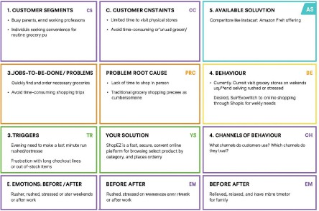

References:

1. <https://www.ideahackers.network/problem-solution-fit-canvas/>
2. [https://medium.com/@epicantus/problem-solution-fit-canvas-aa3dd59cb4fe](https://medium.com/%40epicantus/problem-solution-fit-canvas-aa3dd59cb4fe)